Infosys Springboard Virtual Internship

Project Report

Project Title: Road Accident Data Analysis and Visualization

Domain: Transportation
Internship: Infosys Springboard – Data Visualization Internship

By: Rhutuja Kshirsagar

DATASET OVERVIEW
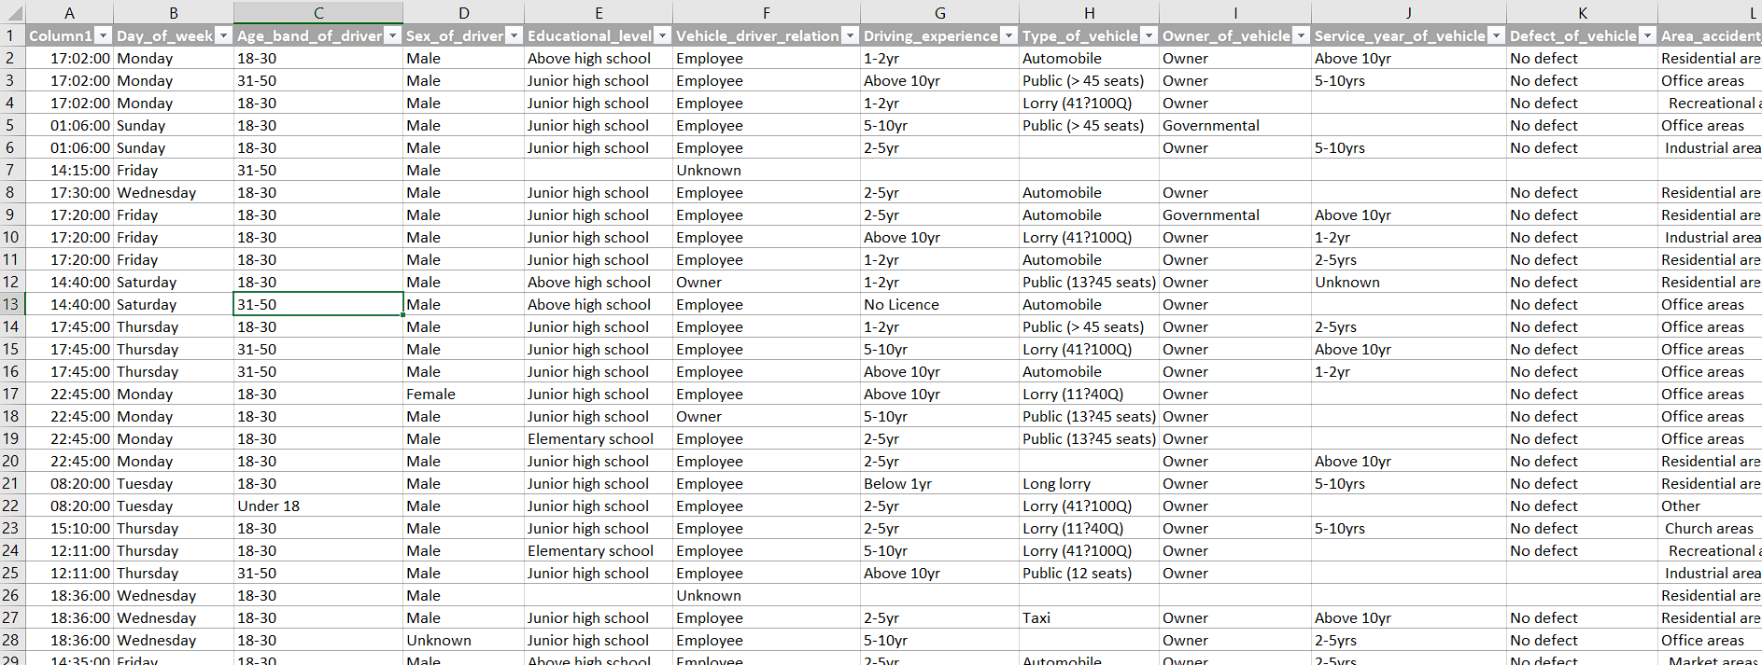

Dataset Name
Road Traffic Accident (RTA) Dataset
Domain
Transportation
File Format
CSV
Total Records
12,316 Accident Records
Total Features
32 Columns
Each row represents one road accident case.

Feature Descriptions

Column Name | Description / What it Represents
Time | The time at which the road accident occurred.
Day_of_week | The day of the week when the accident happened (Monday–Sunday).
Age_band_of_driver | Age group of the driver involved in the accident (e.g., 18–30, 31–50).
Sex_of_driver | Gender of the driver (Male/Female).
Educational_level | Highest education level completed by the driver.
Vehicle_driver_relation | Relationship between the driver and the vehicle (Owner, Employee, Other).
Driving_experience | Number of years of driving experience of the driver.
Type_of_vehicle | Category of vehicle involved (Car, Bus, Truck, Motorcycle, etc.).
Owner_of_vehicle | Ownership of the vehicle (Private, Government, Organization, etc.).
Service_year_of_vehicle | Number of years the vehicle has been in service.
Defect_of_vehicle | Whether the vehicle had any mechanical defects before the accident.
Area_accident_occured | Type of area where the accident occurred (Urban, Rural, Residential, etc.).
Lanes_or_Medians | Information about the number of lanes or presence of a road median.
Road_allignment | Alignment of the road where the accident occurred (Straight, Curved, Sloped, etc.).
Types_of_Junction | Type of road junction (T-junction, Crossroad, Roundabout, No junction, etc.).
Road_surface_type | Material of the road surface (Asphalt, Gravel, Earth, etc.).
Road_surface_conditions | Condition of the road surface during the accident (Dry, Wet, Muddy, etc.).
Light_conditions | Lighting conditions at the accident location (Daylight, Darkness, Dawn/Dusk).
Weather_conditions | Weather at the time of the accident (Clear, Rainy, Foggy, Windy, etc.).
Type_of_collision | Nature of the collision (Head-on, Rear-end, Side collision, etc.).
Number_of_vehicles_involved | Total number of vehicles involved in the accident.
Number_of_casualties | Total number of people injured or killed in the accident.
Vehicle_movement | Movement of the vehicle before the accident (Moving Straight, Turning, Reversing, Parked, etc.).
Casualty_class | Category of casualty (Driver, Passenger, Pedestrian, etc.).
Sex_of_casualty | Gender of the injured or deceased person.
Age_band_of_casualty | Age group of the casualty.
Casualty_severity | Severity of injuries suffered by the casualty (Fatal, Serious, Slight).
Work_of_casuality | Occupation or work status of the casualty.
Fitness_of_casuality | Physical fitness or health condition of the casualty before the accident.
Pedestrian_movement | Movement of the pedestrian during the accident (Crossing, Walking, Standing, etc.).
Cause_of_accident | Main reason responsible for the accident (Overspeeding, Careless Driving, Overtaking, etc.).
Accident_severity | Overall severity level of the accident. This is commonly used as the target variable for analysis and prediction.

DATA CLEANING
- Initial inspection

- df.shape :

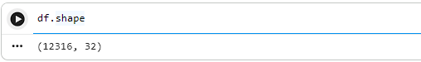
It contains 12316 rows
It contains 32 columns
- df.info():
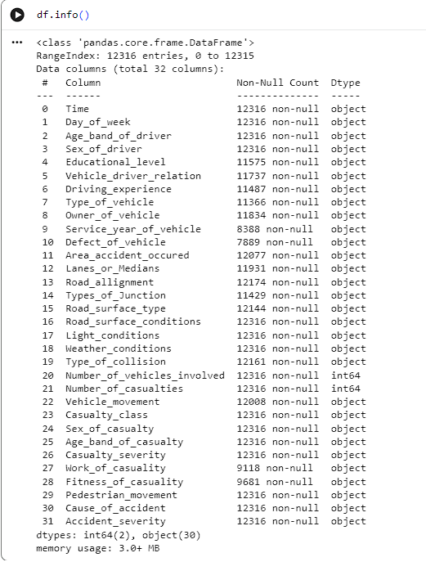

Used to display the dataset's structure, including the number of rows and columns, column names, data types, non-null values, and memory usage.

- Checking Duplicate Records
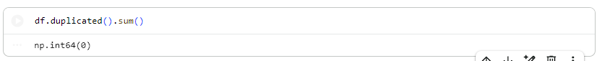

It contains 0 duplicate values

- Explored category distributions for every column

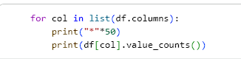
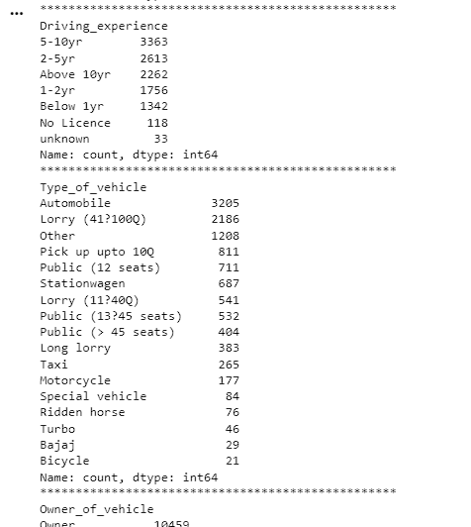
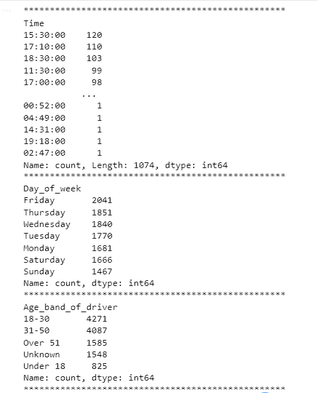
Used to understand the spread of each categorical column, spot rare/messy categories, and decide how each column should be cleaned or imputed.

- Null values :

Checked missing values per column
- df.isnull().sum()

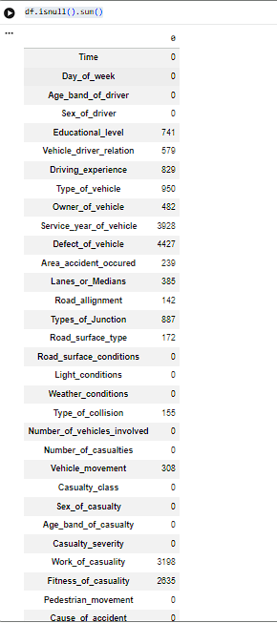

In this it contents 15 plus rows having null value

- Handling Missing value Using Gower Distance

The dataset contains many categorical features. Simple methods such as mean or median imputation are not suitable because they only work with numerical data. Instead, this project used Gower Distance, which measures similarity between records containing both categorical and numerical variables a standard KNN imputer does not directly apply. The Gower distance metric was used instead, as it can compute similarity across mixed data types.

Why Gower Distance?

- Suitable for mixed-type datasets
- Preserves relationships between variables
- Produces more realistic imputations
- Reduces bias compared to simple replacement methods

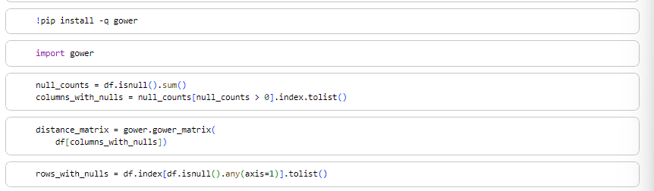
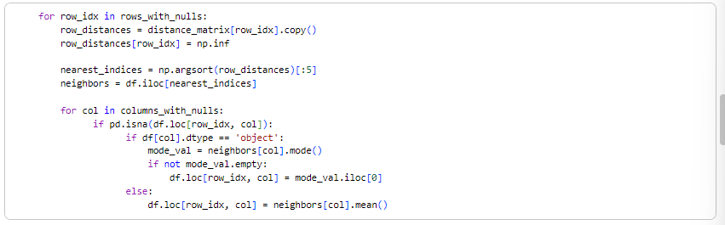

The Process, Step by Step

Step 1 : Get the tool ready Install and load the gower library, which knows how to compare rows of mixed data types.

Step 2 : Find out which columns have gaps Scan every column and make a list of the ones that have missing values (e.g., Weather, Education Level, Vehicle Service Year).

Step 3 : Measure how similar every row is to every other row Using only the columns that have gaps, calculate a "distance" between every pair of rows. A small distance means two rows look alike; a large distance means they don't.

Step 4 : Find out exactly which rows need fixing Make a list of every row that has at least one missing value these are the only rows the process needs to work on.

Step 5 : Bring in a helper library (NumPy) This is just used later for sorting numbers and marking a row as "not a match for itself."

Step 6 : For each row with a gap, find its 5 closest matches
- Look at how far this row is from every other row.
- Ignore the row's distance to itself (it's always 0, so it's excluded by marking it as infinitely far away).
- Sort all the other rows by closeness and pick the 5 most similar ones these become the "neighbors."

Step 7 : Use the neighbors to fill in the missing value

- If the missing value is a category (like Weather or Education Level): look at what those 5 neighbors have in that column, and use whichever value appears most often (the "mode"). Example: 4 out of 5 neighbors say "Clear" weather → the missing value becomes "Clear."

- If the missing value is a number: take the average of the 5 neighbors' values. Example: neighbor values 3, 4, 2, 5, 6 → average is 4 → the missing value becomes 4.

Column Name | Missing Values | Description | Imputation Method
Educational_level | 741 | Education level of the driver. | Filled using the mode (most frequent value) of the 5 nearest similar records identified by Gower Distance.
Vehicle_driver_relation | 579 | Relationship between the driver and the vehicle (Owner, Employee, etc.). | Filled using the mode of the 5 nearest neighbours.
Driving_experience | 829 | Driver's years of driving experience. | Filled using the mode of the 5 nearest neighbours because it is treated as a categorical variable.
Type_of_vehicle | 950 | Type of vehicle involved in the accident. | Filled using the mode of the nearest similar records.
Owner_of_vehicle | 482 | Ownership of the vehicle (Private, Government, Organization, etc.). | Filled using the mode of the nearest neighbours.
Service_year_of_vehicle | 3,928 | Number of years the vehicle has been in service. | Filled using the mean (average) of the 5 nearest neighbours if stored as a numerical column; otherwise mode if categorical.
Defect_of_vehicle | 4,427 | Indicates whether the vehicle had any mechanical defect. | Filled using the mode of the nearest similar records.
Area_accident_occured | 239 | Area where the accident occurred (Urban, Residential, Rural, etc.). | Filled using the mode of the nearest neighbours.
Lanes_or_Medians | 385 | Number of lanes or presence of a road median. | Filled using the mode of the nearest neighbours.
Road_allignment | 142 | Road alignment (Straight, Curved, Sloped, etc.). | Filled using the mode of the nearest neighbours.
Types_of_Junction | 887 | Type of road junction where the accident occurred. | Filled using the mode of the nearest neighbours.
Road_surface_type | 172 | Surface material of the road (Asphalt, Gravel, Earth, etc.). | Filled using the mode of the nearest neighbours.
Type_of_collision | 155 | Type of collision (Head-on, Rear-end, Side collision, etc.). | Filled using the mode of the nearest neighbours.
Vehicle_movement | 308 | Movement of the vehicle before the accident (Moving Straight, Turning, Reversing, etc.). | Filled using the mode of the nearest neighbours.
Work_of_casuality | 3,198 | Occupation of the casualty. | Filled using the mode of the nearest neighbours.
Fitness_of_casuality | 2,635 | Physical fitness or health condition of the casualty before the accident. | Filled using the mode of the nearest neighbours.

- Categorical columns → Similar categories were merged into a single category to reduce complexity and improve analysis.
- Rare categories → Combined into an "Other" category where appropriate.
- Driving experience → Merged "No licence" with "Unknown" to maintain a consistent category.
- Type_of_vehicle → Merged all vehicle types except "Bajaj" into a single category called "Other" to reduce category complexity
Cleaned up inconsistent category labels
- "No Licence" inside Driving experience was recoded to "unknown" for consistency with the rest of the column's labelling
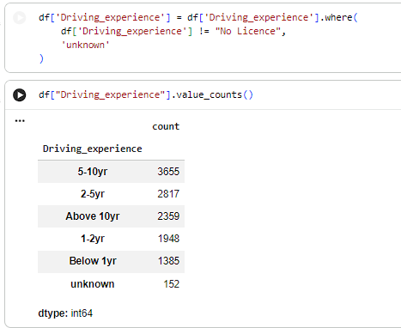

- "Bajaj" inside Type_of_vehicle (only 29 records) was folded into the "Other" category, since it was too rare to remain a standalone class:

- Check Null Values
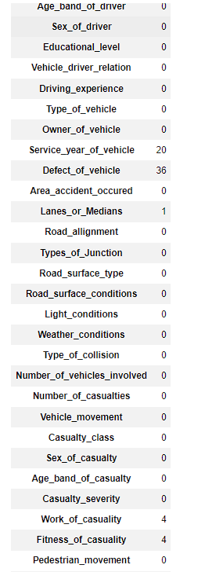
Rechecking null counts after this step showed almost every column fully filled, with only a handful of residual gaps left in a few columns
6. Dropped remaining rows with residual nulls
The last few unfilled values (Service_year_of_vehicle, Defect_of_vehicle, Lanes_or_Medians, Work_of_casuality, Fitness_of_casuality) were dropped, since they were a very small fraction of the dataset
